Create a FREE account on MongoDB atlas

https://www.mongodb.com/cloud/atlas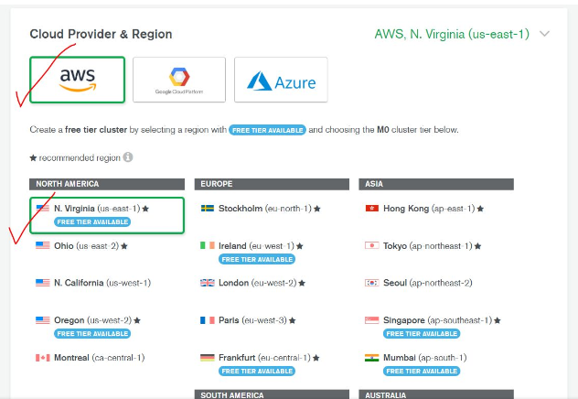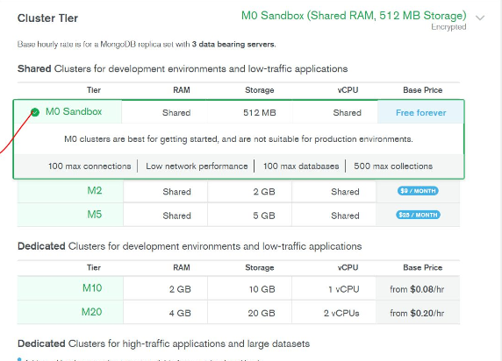

1. Create a new cluster with given configurations.

2.CHOOSE M0 Sandbox Tier as it is Free!

3. Give name to your free cluster.

4.Add a new user and set the credentials (this will be required in connection string).

5.Whitelist Current IP or all IP addresses to access the cluster remotely

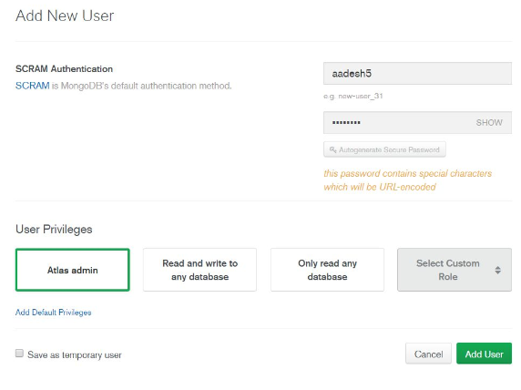

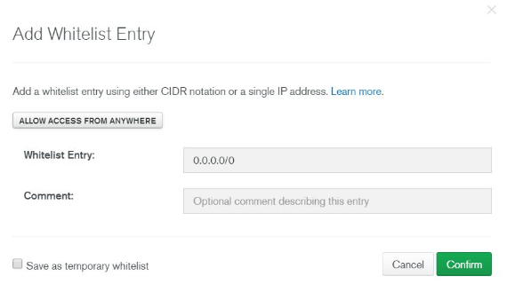

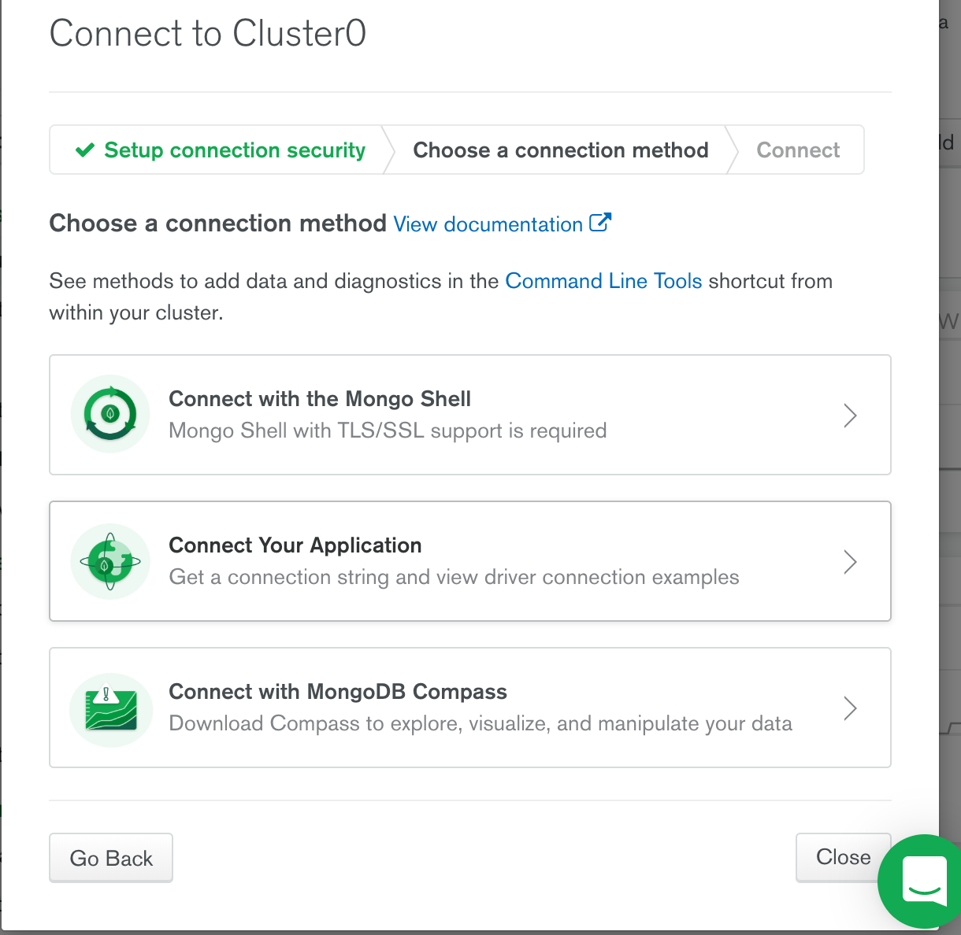

Im choosing connect your application, mongo shell and mongo compass could also be connected with atlas

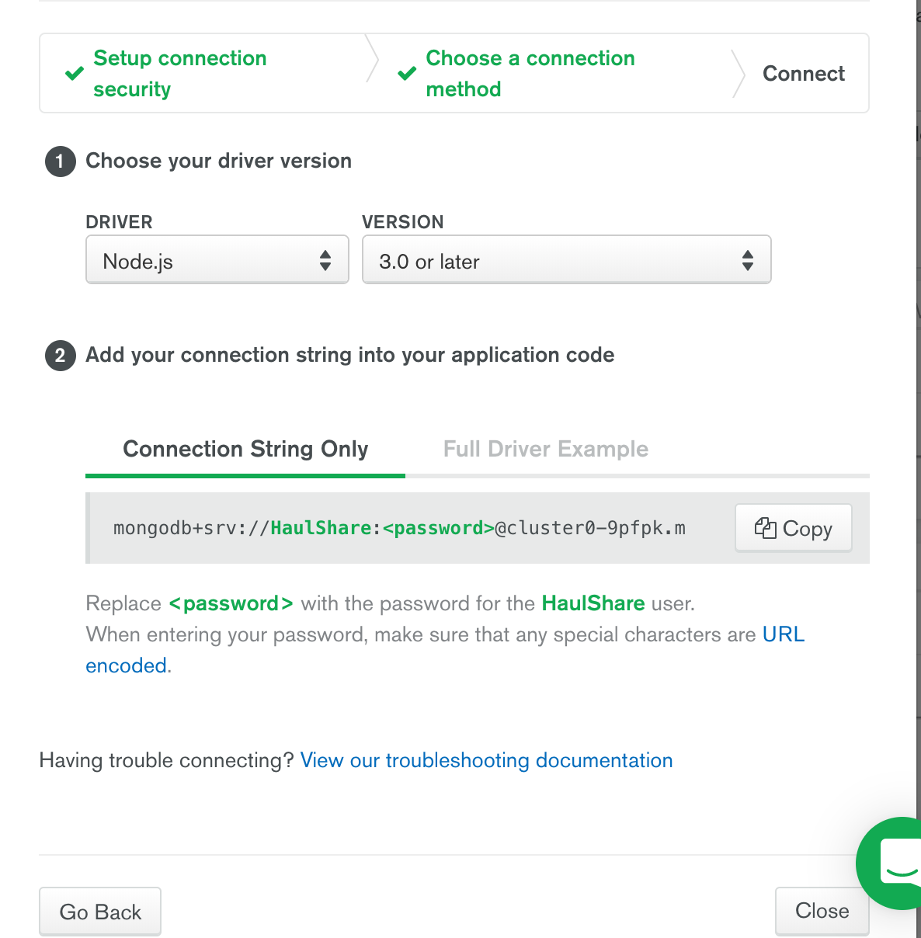

Copy the URL, replace password with cluster pwd

//remote server

const mongo_url =“ ENTER URL HERE";

var database;

MongoClient.connect(mongo_url, function(err, client) {

if (err) {

console.log(err);

return;

}

//remote mongodb

database = client.db(“Db_HaulShare");

});

WiredTiger connection error in local mongo setup:

COMPLETELY UNINSTALL MONGODB IN MAC:

launchctl list | grep mongo

launchctl unload ~/Library/LaunchAgents/homebrew.mxcl.mongodb.plist

launchctl remove homebrew.mxcl.mongodb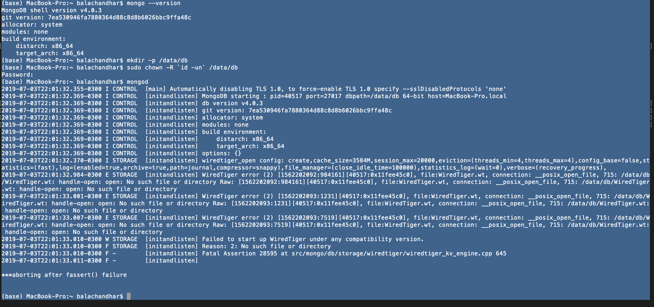

pkill -f mongod

rm -f ~/Library/LaunchAgents/homebrew.mxcl.mongodb.plist

brew uninstall mongodb

//CHECK IF THE FILE EXISTS

ls -al /usr/local/bin/mong*

ls -al ~/Library/LaunchAgents

INSTALL MONGODB:

brew tap mongodb/brew

brew install mongodb-community@4.0

brew services start mongodb-community@4.0

mongod --config /usr/local/etc/mongod.conf

mongo

Local some useful comments:

show databases

use database_name

show collections

db. database_name.find()